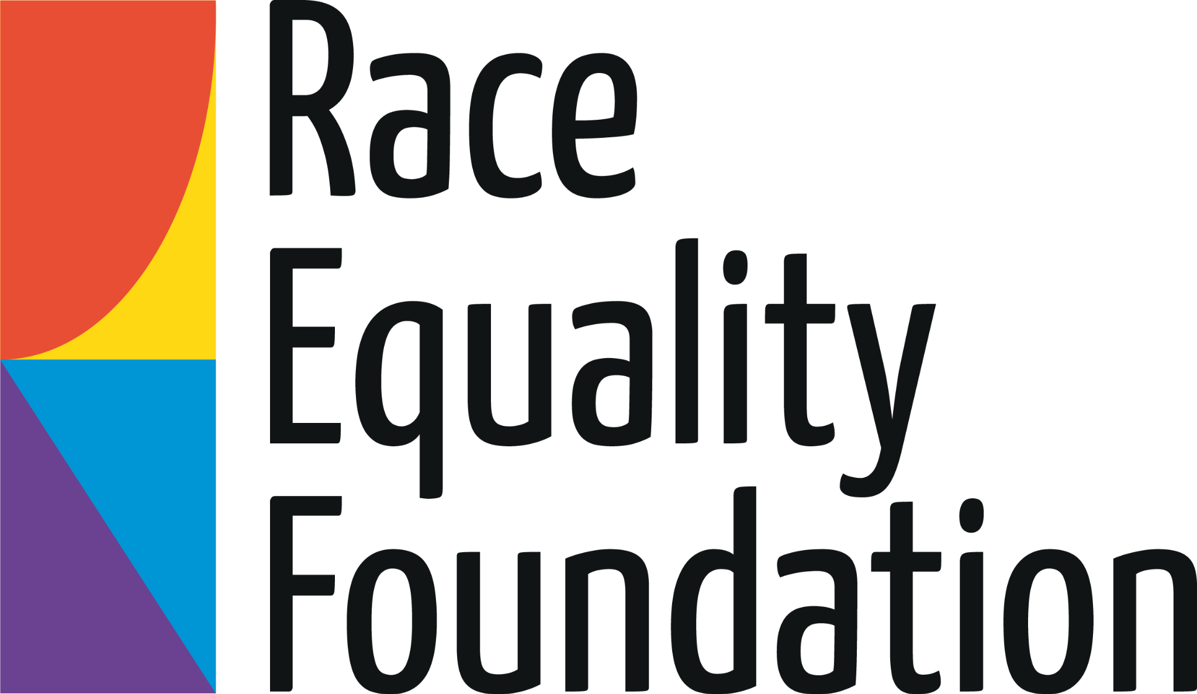

CONFIDENTIAL

APPLICATION FORM

Post: Peer Researcher – Safer Lives Project

To apply for this role, you can choose one of the following options:

- Complete a written application form

- Send us a video or audio file with your answers to the questions

- Answer the questions on this form over the phone

Please contact Programme Co-ordinator, Sally Opoku Donkor, at sally-ann@racefound.org.uk when sending us your application

You will also need to complete a separate monitoring form.

Deadline: Monday 17th August 12pm

How to apply
You can choose the way that suits you best:
1. Complete this form in writing (typed or handwritten).
2. Record a short video or voice note answering the questions below (no longer than 3 minutes).
3. Have a chat with us by phone or video call – we can record your answers together.
If you need support to apply or want to talk about the role first, email leandra@racefound.org.uk or sally-ann@racefound.org.uk
Your information
Name
Date of Birth
Home address
Phone
Email
Where did you hear about this opportunity?

About you
We’re interested in who you are, not just your education or work history. You can use examples from any part of your life - home, school, community, caring for others, or your own experiences.
Please answer the questions below in writing, or through a video or voice note recording.
If you are writing the answers, you can add your answers in the space under each question below, please write no more than 250 words for each question.

1. Why are you interested in becoming a Peer Researcher for the Safer Lives project? (What interests you about helping young people through research?)
We’re looking for people who genuinely care about young people and are committed to making a positive difference in their lives - not just people with lots of research experience.
2. How would you go about starting conversations or helping people feel comfortable to share their stories?
This role is about working with other young people to understand their views and experiences and we need to be able to build trust with them.
3. Can you tell us about a time when you started something new and share some examples of the kinds of things that helped you to get organised and find your way as you learned?
For this role, you don't need to have loads of work experience - you can learn on the job.
4. What lived experience do you bring that might help you connect with young people in this project?
By lived experience, we mean understanding that comes from your own life - for example, having been affected by offending, school exclusion, being in care, policing, or violence, or seeing friends or family go through similar things - and wanting to use that experience to help others.
Declaration
I confirm that the information I have provided is true to the best of my knowledge.
Please sign and date the box below (you can add a text or written signature)
Signature
Date
How to return your application
Please send us your application via email to: sally-ann@racefound.org.uk
Your application should include:
- This completed written application form
or
- An audio file
or
- A video file
If you prefer, you can request a call to record your answers.
As well as emailing us your information, please can you complete this short monitoring form so that we can understand who our job vacancies are reaching.
We ask all people who want to work for us to give us some information about themselves, like what their ethnicity is or if they have a disability. We ask for this information to help us see who our opportunities are reaching. It isn’t shared with the people making recruitment decisions and doesn’t affect your application. It just helps us understand how fair and inclusive our process is, and where we might need to improve in the future.

